Lab 13 - .NET - Dev - Connecting Key Vault to an Azure web app in .NET
Estimated Duration: 30 minutes
Lab type: Instructor led
Objective
In this lab, you'll create and deploy Azure web application to Azure App Service. You'll use a managed identity to authenticate your Azure web app with an Azure key vault using Azure Key Vault secret client library for .NET and the Azure CLI.

Exercise 1. Publish your web app
To publish your web app, you must first create and configure a new App Service that you can publish your app to. You will be publishing the same app that we forked in the Lab 01 - .NET-Dev - Creating and deploying a web app using Azure App Service.
As part of setting up the App Service, you create:
- A new resource group to contain all the Azure resources for the service.
- A new Hosting Plan that specifies the location, size, and features of the web server farm that hosts your app.

Task 1: Create the App service plan and app in Azure
Follow these steps to create your App Service resources and publish your project:
- Login to Azure at https://portal.azure.com. Type app services in the search bar. Under Services, select App Services.
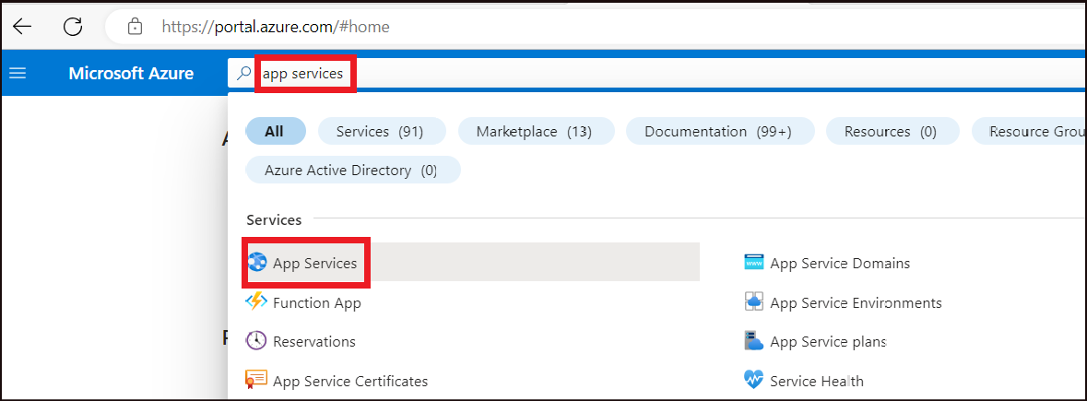
- In the App Services page, select the drop down next to + Create and then select Web App.
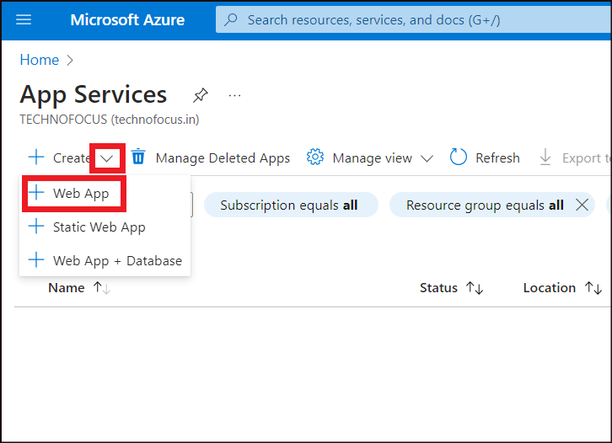
- In the Basics tab ->Project Details, enter the below details.
Property | Value
Resource Group | Create New ->RGForAppService
- 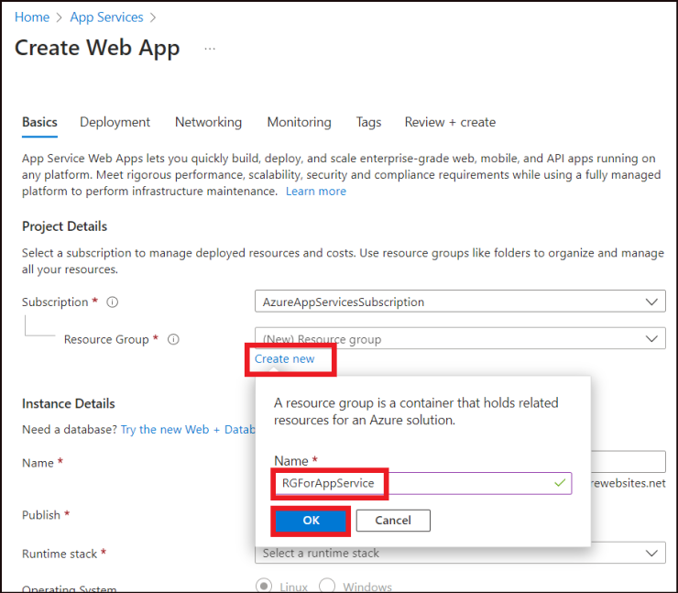
- In the Basics tab ->Instance Details, enter the below details.
Property | Value
Name | dotNetAzureWebApp99 (This name should be globally unique. Replace 98 with any random number to ensure uniqueness)
Publish | Select Code
Runtime stack | Select .NET 7 (STS)
Operating System | Windows
Region | East US
- 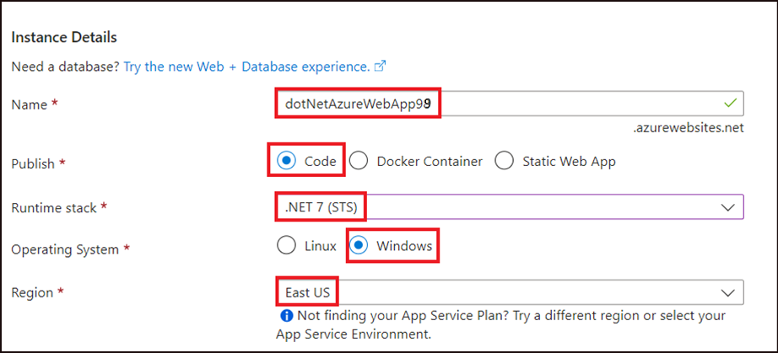
- In the Basics tab ->Pricing plans, enter the below details.
Property | Value
Windows Plan | Create new ->myAppServicePlan
Pricing plan | Free F1
- 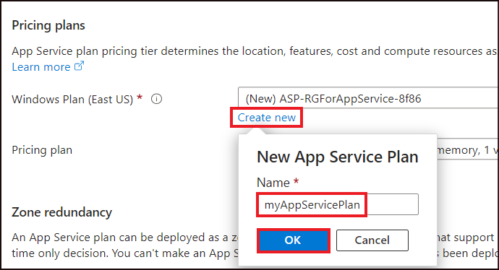
- 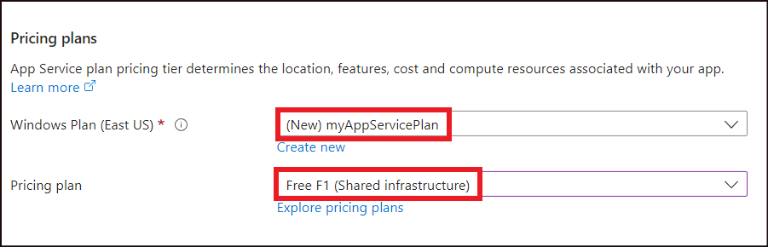
- Click on Next: Deployment.
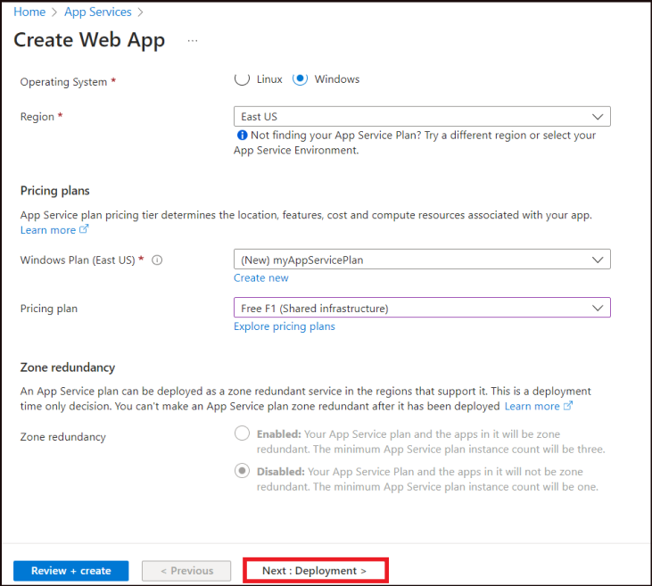

Task 2: GitHub Actions that enables Continuous deployment
- In the Deployment tab, Enable the Continuous deployment under GitHub Actions settings.
- Under GitHub Actions details, it would have already been authorized and will display your GitHub account name.
- Select the following options:
Property | Value
Organization | Select GitHub account where you have forked the repo
Repository | Select dotnetcore-core-api
Branch | master
- Select Next : Networking >.
- 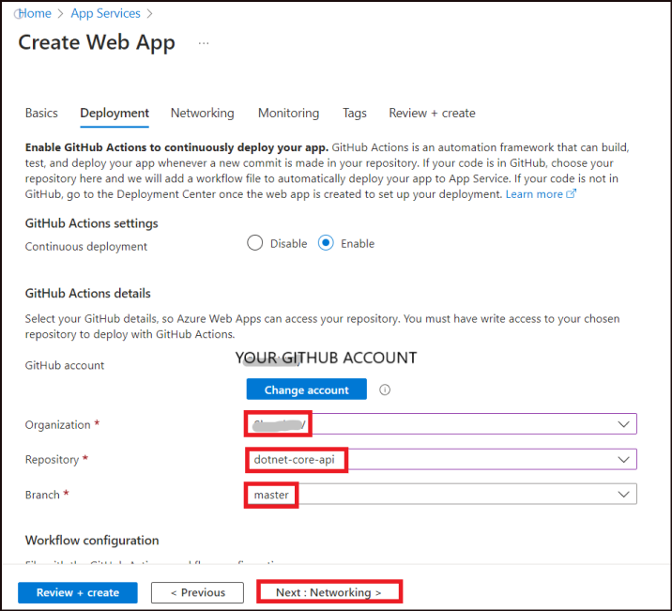
- On the Networking tab, accept the defaults and click on Next : Monitoring > .
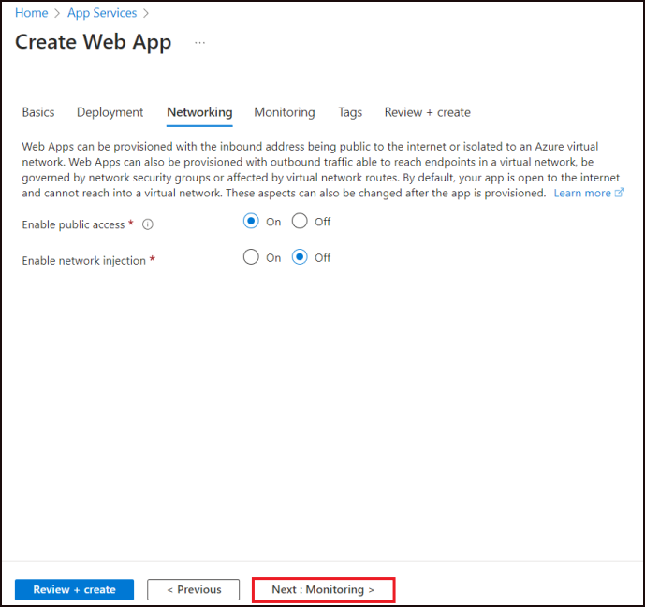
- On the Monitoring tab, ensure that Yes is selected for the Enable Application Insights option. Select Review + Create.
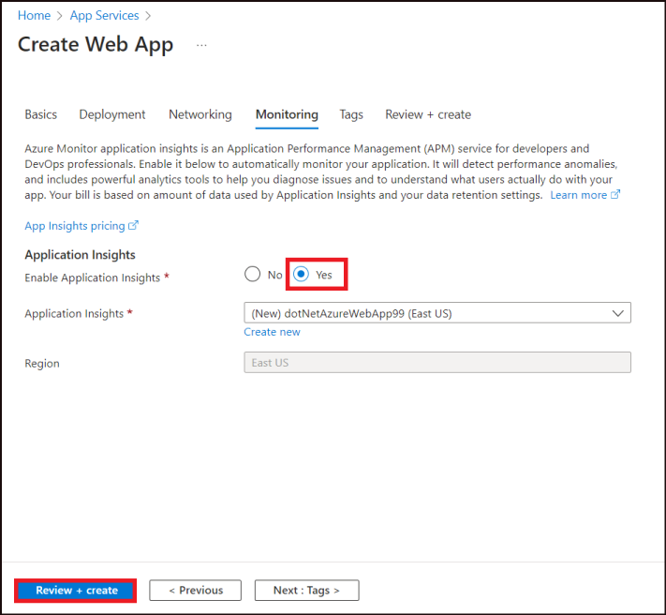
- After validation runs, select the Create button at the bottom of the page.
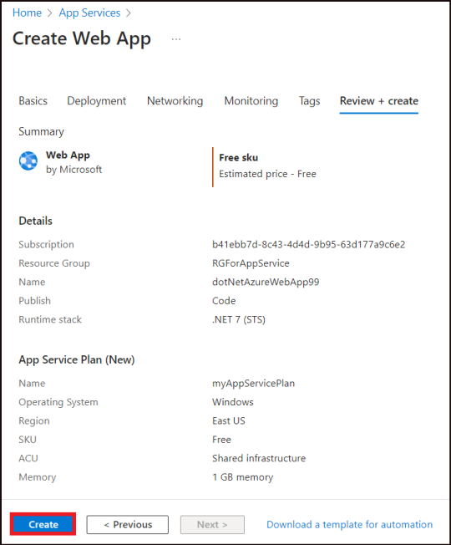
- After deployment is complete, select Go to resource.
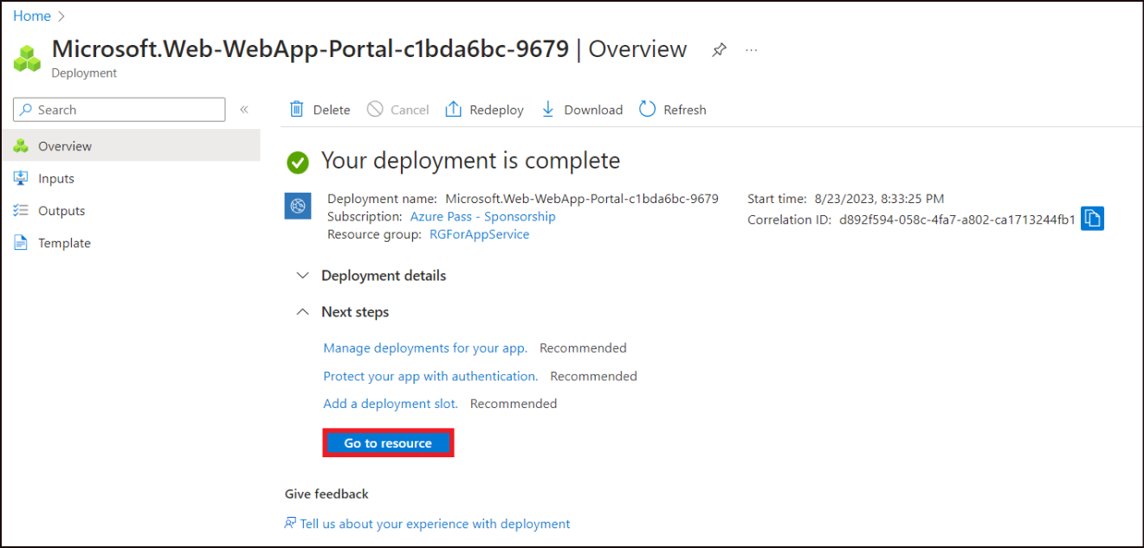
- This is the place to manage the web app. The Default domain name gives the url for the app. Click on it.
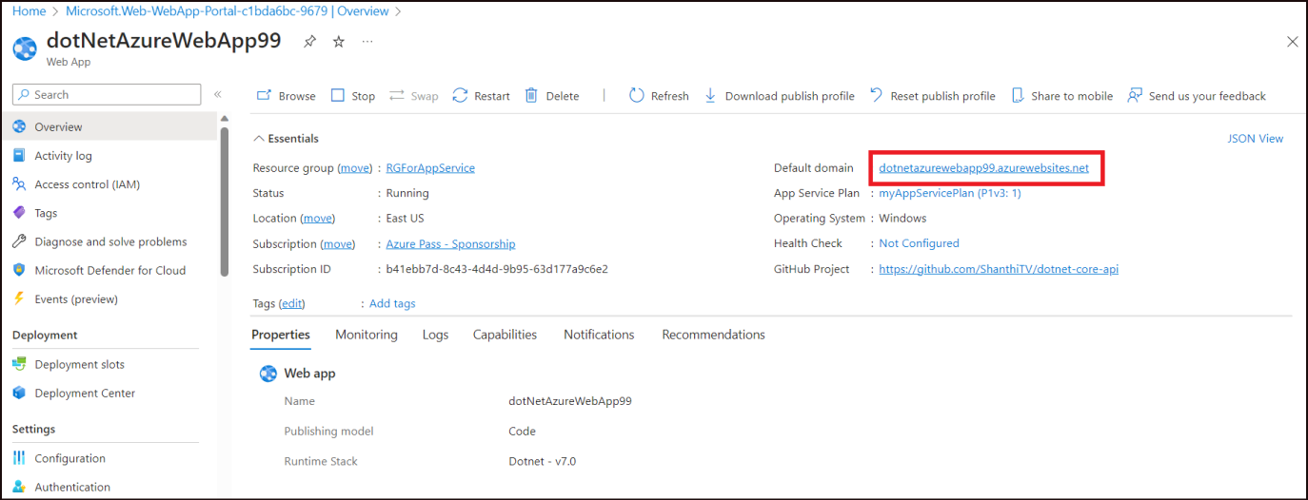
- It opens up the app that we have deployed in Azure.
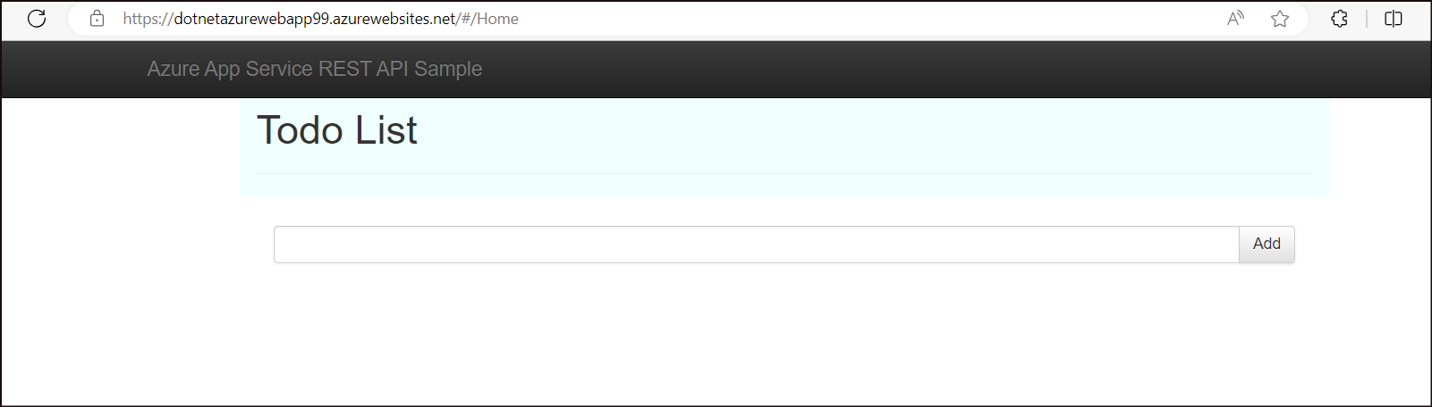

Exercise 2: Create managed identity and Azure Key Vault
Important: If the commands does not get pasted using the T button into the CloudShell, please copy and paste them manually or paste it in the Notepad, edit it as per the instructions if needed and then paste it into the CloudShell.

Task 1: Create and assign a managed identity
- Back in the Azure portal, open Cloud Shell by clicking on the cloud shell icon.
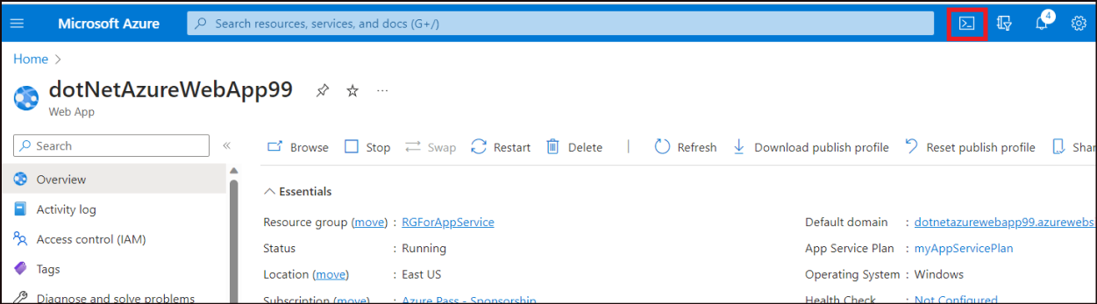
- We will use managed identity to authenticate to Key Vault. Managed identity automatically manages application credentials.
- In the Azure CLI, to create the identity for the application, run the az webapp-identity assign command as below, replacing,
  - "<your-webapp-name>" - dotNetAzureWebApp99 (Replace 99 with the random number you had used during the app creation
  - "<your ResourceGroup>" - RGForAppService
az webapp identity assign --name "<your-webapp-name>" --resource-group "<your ResourceGroup">
In this case, the command will be as below.
az webapp identity assign --name "dotNetAzureWebApp99" --resource-group "RGForAppService"
- This command executes and outputs the principalId, tenantId and type as output as shown in the screenshot below. Copy the output and paste it in a notepad for use in the next steps.
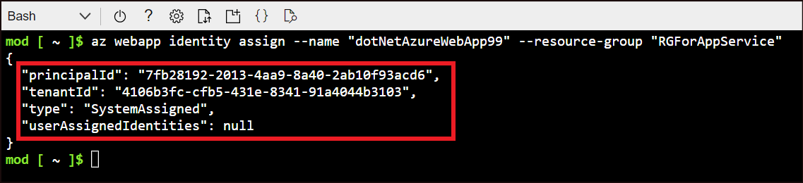

Task 2: Create an Azure Vault and assign secret
- We will create an Azure Key Vault and assign secret to it.
- Execute the below command to create the Azure Key Vault replacing
  - "<YourKeyVaultName>" – myKeyVaultXXXX (Replace XXXX with a random number so that the name is globally unique)
  - "<YourResourceGroupName>" - RGForAppService
az keyvault create --name "<YourKeyVaultName>" --resource-group "<YourResourceGroupName>" --location "East US"
In this case, the command will be as below,
az keyvault create --name "myKeyVault89" --resource-group "RGForAppService" --location "East US"
- Once the key vault is created, a provisioning state: succeeded message is populated in the Cloud Shell.
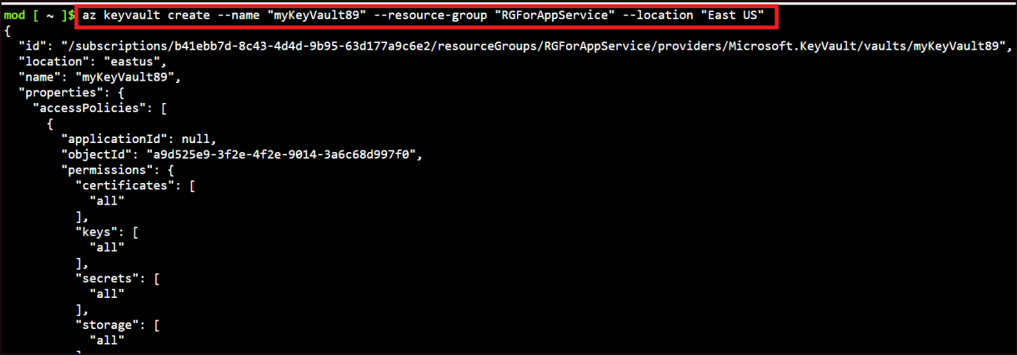
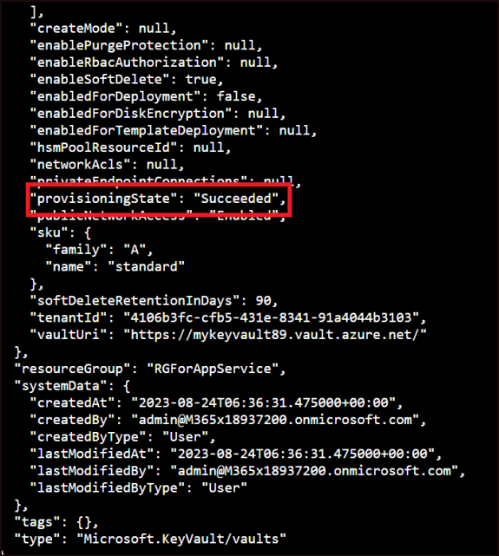
- This command will create a Azure Key Vault named myKeyVault89 under the Resource group RGForAppService in the EastUS location.
- Execute the below command to create a secret for the created Key Vault replacing “<vault-name>” with Your KeyVault name .
az keyvault secret set --vault-name "<vault-name>" --name "AppSecret" --value "MySecret"
In this case, the command will be as below.
az keyvault secret set --vault-name "myKeyVault89" --name "AppSecret" --value "MySecret"
- Once the secret is created, the details are populated in the Cloud Shell as in the below screenshot.
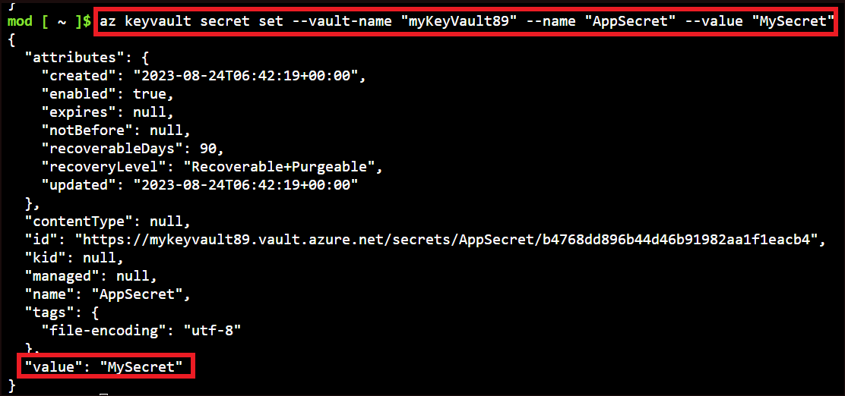
- Execute the below command replacing the
  - < your-keyvault-name > with myKeyVault89 (replacing 89 with the random number you had used.
  - principalId with the principal ID that we had noted down from the managed identity.
az keyvault set-policy --name "< your-keyvault-name >" --object-id "< principalId >" --secret-permissions get list
- Once executed, a provisioning : Succeeded message is obtained on the screen.
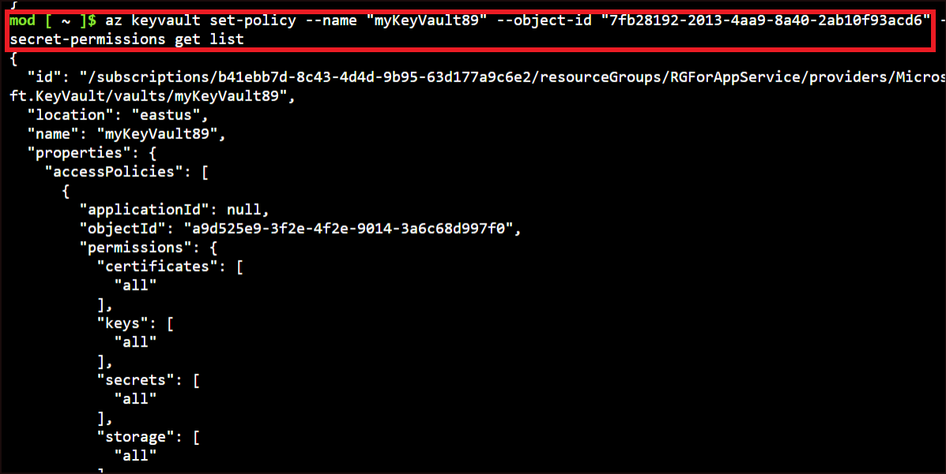
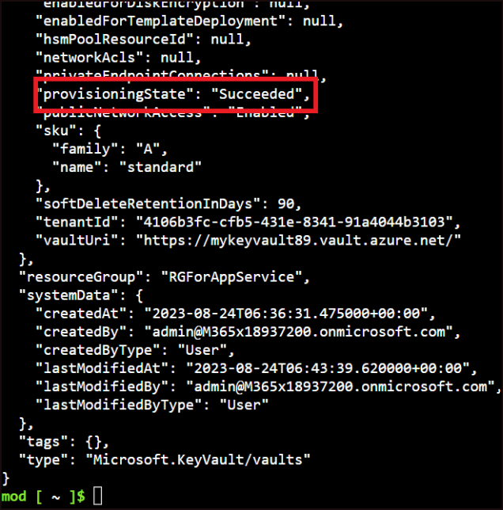
- This command gives your web app, permission to do get and list operations on your key vault.

Task 3: Access the secret:
- From your GitHub repo, navigate to forked repo dotnet-core-api and open Startup.cs and select Edit in place.
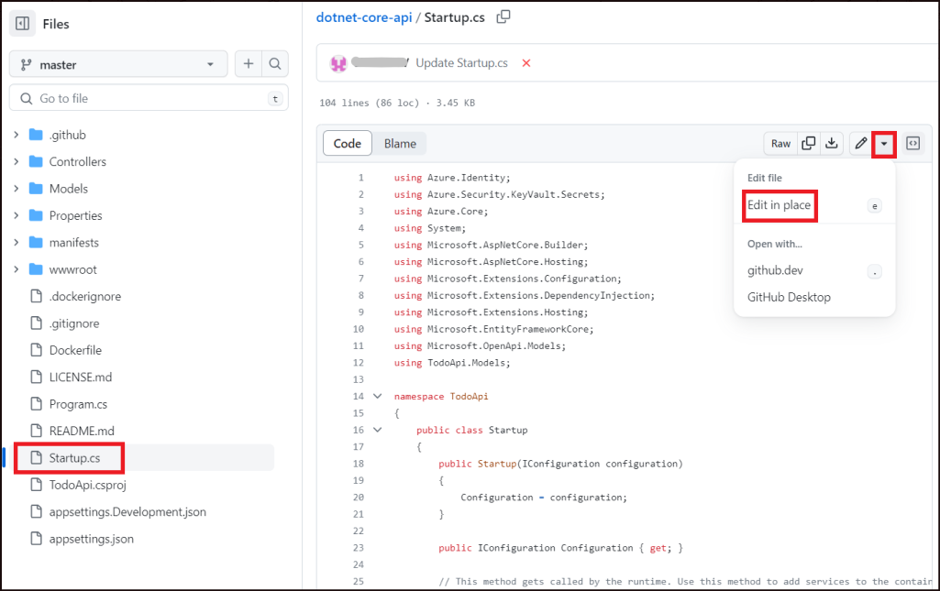
- Uncomment the commented block. Remove the comment mark from line 28, 42 and 49.
- Replace the keyvault name(mykeyvault89) in the url, in line number 38, with your key vault name.
- Comment the line number 48.
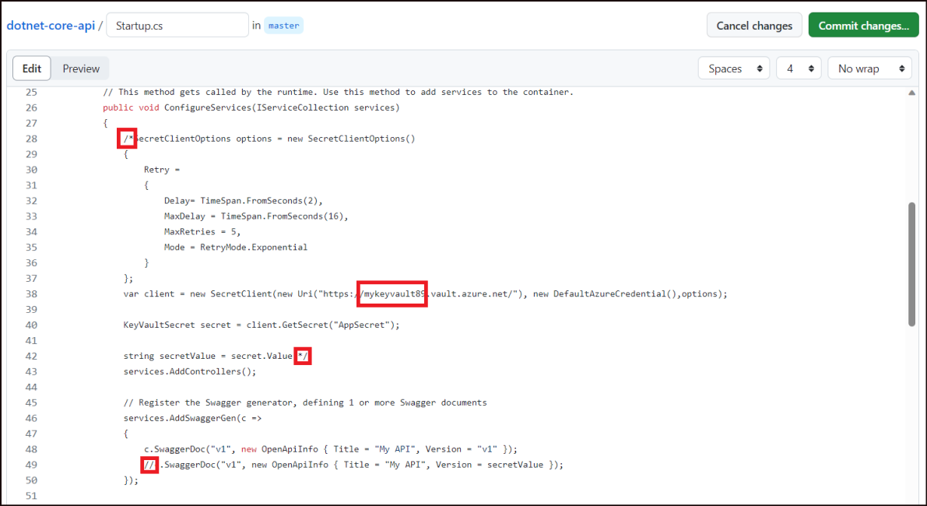
- The file should now look like this. Click on Commit changes.
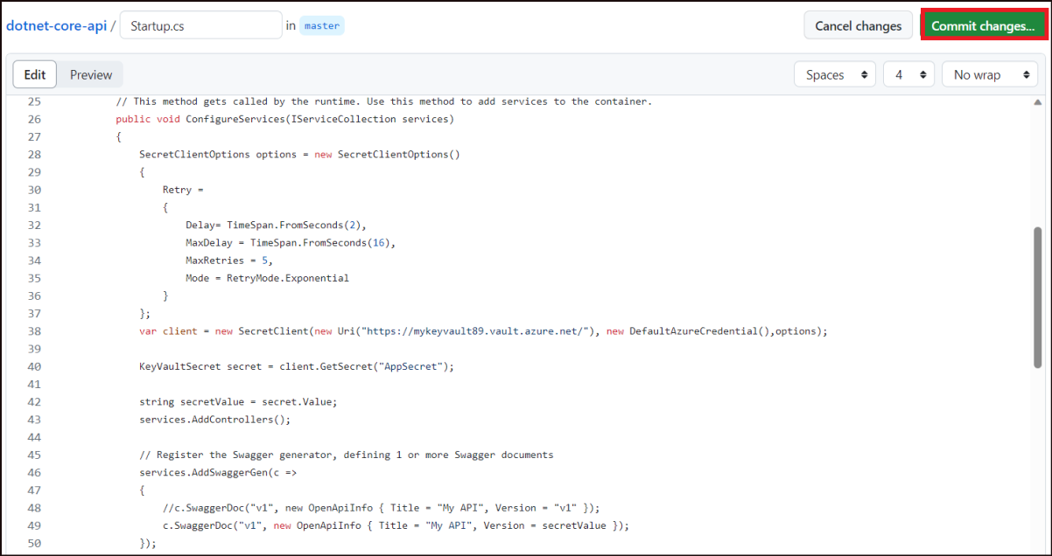
- Click on Commit changes again.
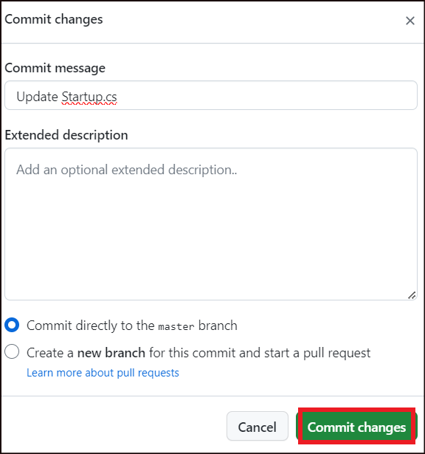
- The Commit will invoke a workflow. Click on Actions to view the progress of the flow.
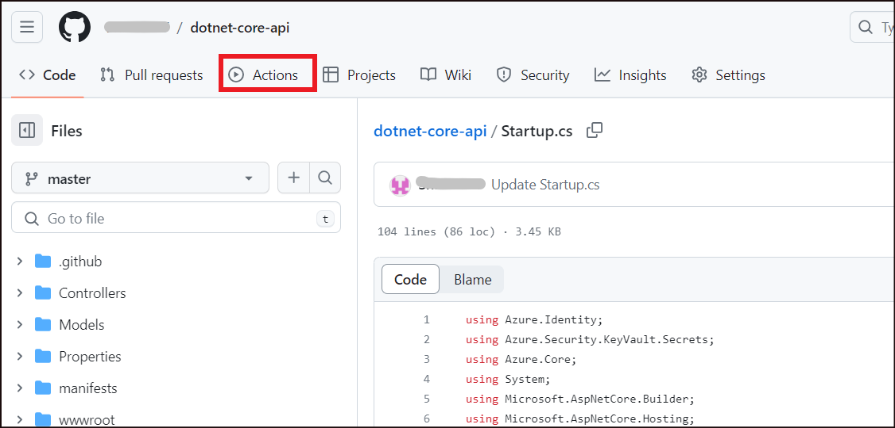
- This will take you to the workflow page. From the left pane, select your application that you deployed now. (Build and deploy ASP.Net Core app to Azure Web App - dotNetAzureWebApp99) Click on the workflow – Update Startup.cs to follow it.
Note: There might be other workflows from previous deployments that might fail since we are using the same repo. Please ignore the others and select and monitor the one corresponding to your recently deployed app only.
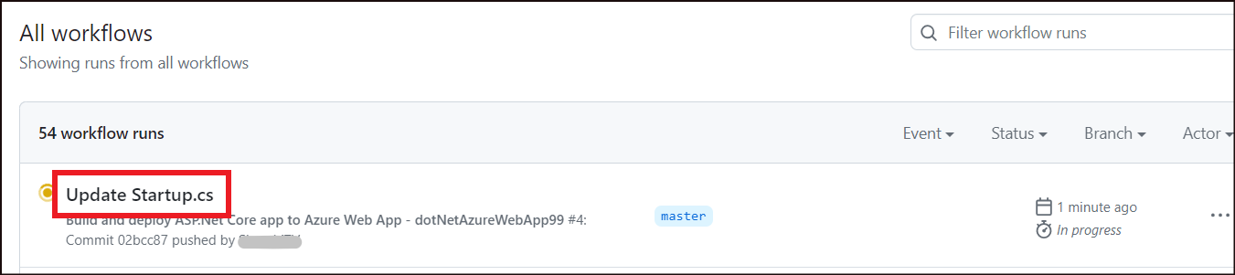
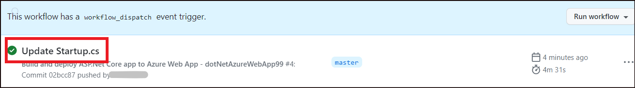
- Now, open the app from the browser. You can click on the link in the Overview page of the App service.
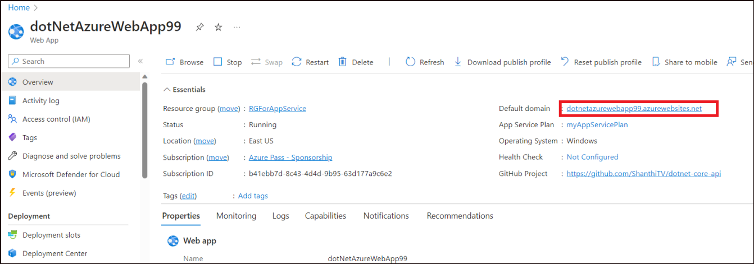
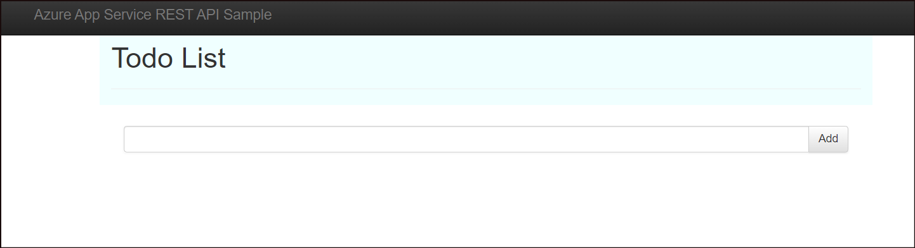
- Navigate to app name>.azurewebsites.net/swagger/index.html (Add swagger to the end of the existing url).
You can see the Key Vault secret next to My API.
We have now accessed the secret from the Key Vault.
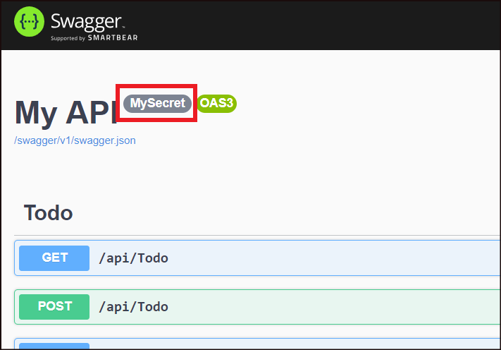
Summary:
Congratulations! You have successfully completed this lab and learnt how to use managed identity to authenticate your Azure web app with an Azure key vault.

